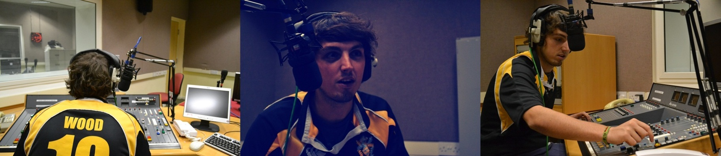
“Determined, creative, confident and hard-working journalism student”
Education
University of Central Lancashire
Broadcast Journalism
BJTC Accredited
Media Law
Public Administration
I News
Avid
Burli
Old Swinford Hospital School
A-Level
Biology, Psychology & English Literature
Contact Details
rwood@uclan.ac.uk
07875148564
Twitter: @woody44z
2 Penrose Road, Gloucester. GL3 1BZ
Ryan Wood

Journalism Experience

Gloucestershire Echo – Sports Writer/Researcher (December 2010)
- Writing articles on a variety of sporting topics.
- Conducting interviews for the related articles.
- Correcting and re-writing sport headlines.
- Sub-editing articles for punctuation, news style and spelling.
The Graduate Times – Contributor (September 2011 – Present)
- Sourcing relevant sport stories.
- Writing feature articles focussing on a vast array of sports.
- www.graduatetimes.com
The Sporting Opinion – Founder/Editor/Writer (August 2010-Present)
- Created website with a variety of featured blogs.
- Edit and correct written work by colleagues.
- Source relevant articles from across the internet, teaming up with other bloggers.
- Writing sport articles, including personal audio and video work.
- 11,500 hits in early stages.
- www.thesportingopinion.weebly.com
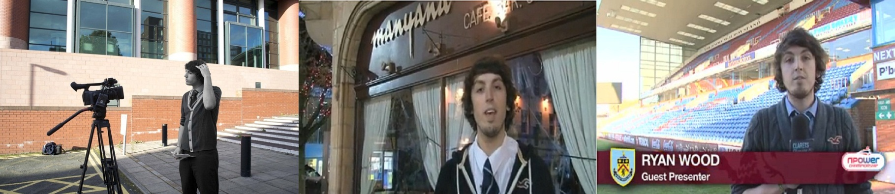
Farmers Guardian – Deputy Web Editor (November 2011 – Present)
- Sub-Editing and transferring content from the newspaper to the website.
Peterborough United FC – Trainee Journalist (December 2011)
Ryan Wood
Journalistic Skills
Writing
Editing (TV & Radio)
Research
Interviewing
Live Studio Production
Multimedia Work
Technically Trained
Personal Skills
Organised
Punctual
Flexible
Committed
Hard-Working
Dedicated
Team Work
Interests
Sport
Music
Social Media

- Created website and match programme content.
- Interviewed Players and Celebrities for articles.
- Edited match footage using Final Cut Pro.
Burnley FC – Trainee Journalist (January 2012)
- Produced, shot and edited a 5-minute ‘behind the scenes’ documentary.
- Created content for the club website.
- Wrote match-day notes for the visiting team.
BBC Radio Gloucestershire – Broadcast Assistant (April 2012)
- Two weeks work placement at the BBC as a Broadcast Assistant (Sport).
- Following Cheltenham Town and Gloucester Rugby over the Easter period for BBC Radio.
Brigg FC – Website Editor/Creator (October 2011 – Present)
- Creating multimedia content.
- Match reports, videos and match galleries.
- Part of a community journalism project
- www.briggfc.weebly.com

